**Name: Karthick R**

**Project Platform: Big Query**

**PROJECT BIG BAZZAR**

**Project Description:**

The Bigbazzar project examines Target's Brazilian operations through a dataset of 100,000 orders from 2016 to 2018. This analysis provides a detailed look at order status, pricing, payment and shipping performance, customer locations, product attributes, and reviews. By exploring this data, the project aims to uncover insights into order processing, pricing strategies, payment and shipping efficiency, customer demographics, product characteristics, and overall satisfaction in Target's Brazilian market.

Question:

1. Data type of all columns in the "customers" table.

Output

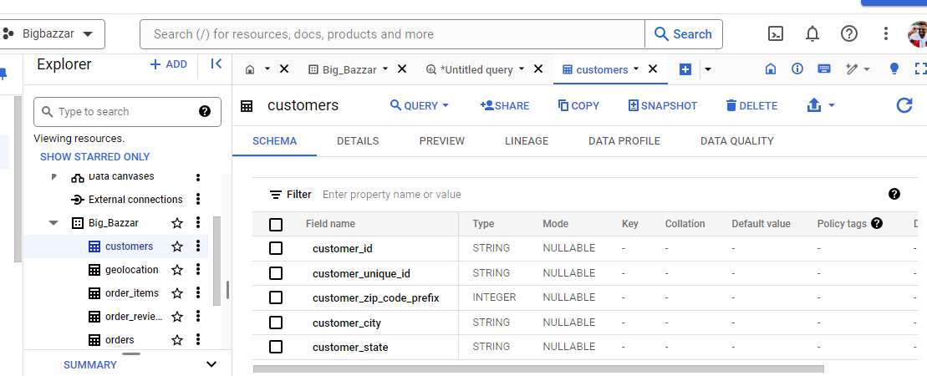

**B** Get the time range between which the orders were placed.

Output

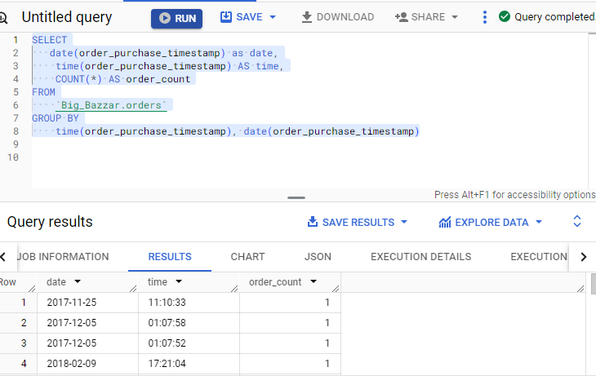

Query

SELECT

   date(order_purchase_timestamp) as date,

    time(order_purchase_timestamp) AS time,

    COUNT(*) AS order_count

FROM

    `Big_Bazzar.orders`

GROUP BY

    time(order_purchase_timestamp), date(order_purchase_timestamp);

**C**.Count the Cities & States of customers who ordered during the given period

Output

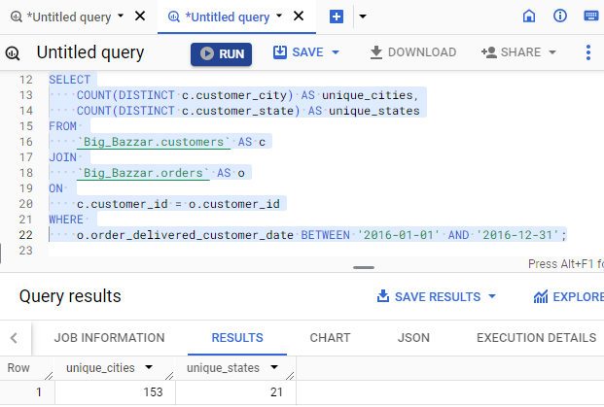

Query

SELECT

COUNT(DISTINCT c.customer_city) AS unique_cities,

COUNT(DISTINCT c.customer_state) AS unique_states

FROM

`Big_Bazzar.customers` AS c

JOIN

`Big_Bazzar.orders` AS o

ON

c.customer_id = o.customer_id

WHERE

o.order_delivered_customer_date BETWEEN '2016-01-01' AND '2016-12-31';

**In-depth Exploration:**

**A** Is there a growing trend in the no. of orders placed over the past years?

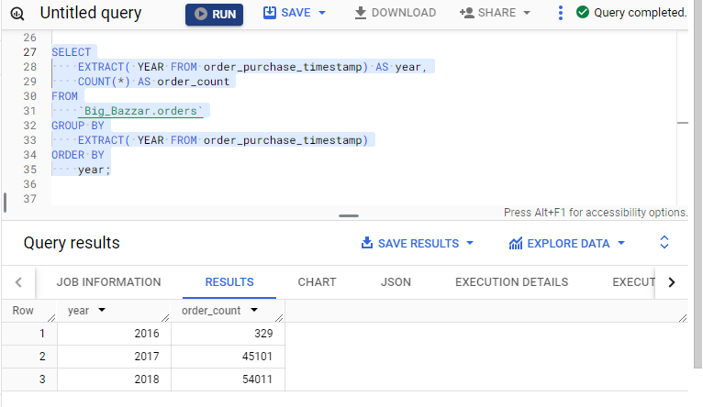

SELECT

    EXTRACT( YEAR FROM order_purchase_timestamp) AS year,

    COUNT(*) AS order_count

FROM

    `Big_Bazzar.orders`

GROUP BY

    EXTRACT( YEAR FROM order_purchase_timestamp)

ORDER BY

    year;

**B** Can we see some kind of monthly seasonality in terms of the no. of orders being placed?

**OUTPUT**

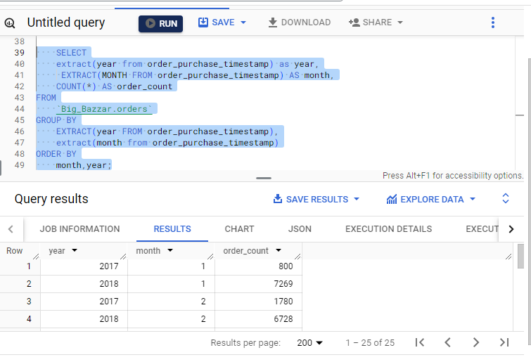

**Query**

    SELECT

    extract(year from order_purchase_timestamp) as year,

     EXTRACT(MONTH FROM order_purchase_timestamp) AS month,

    COUNT(*) AS order_count

FROM

    `Big_Bazzar.orders`

GROUP BY

    EXTRACT(year FROM order_purchase_timestamp),

    extract(month from order_purchase_timestamp)

ORDER BY

    month,year;

**C** During what time of the day, do the Brazilian customers mostly place their orders? (Dawn, Morning, Afternoon or Night)

Output

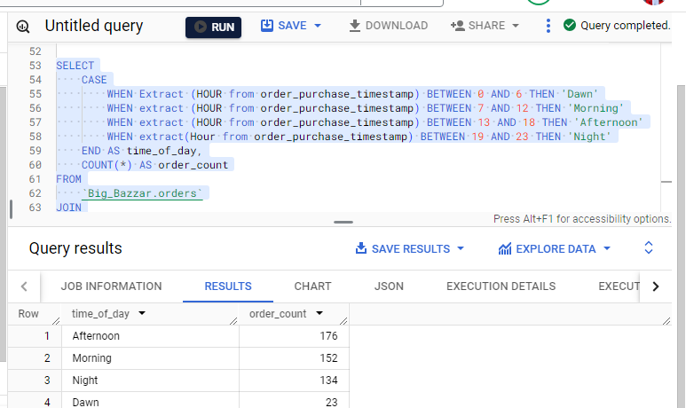

Query

SELECT

    CASE

        WHEN Extract (HOUR from order_purchase_timestamp) BETWEEN 0 AND 6 THEN 'Dawn'

        WHEN extract (HOUR from order_purchase_timestamp) BETWEEN 7 AND 12 THEN 'Morning'

        WHEN extract (HOUR from order_purchase_timestamp) BETWEEN 13 AND 18 THEN 'Afternoon'

        WHEN extract(Hour from order_purchase_timestamp) BETWEEN 19 AND 23 THEN 'Night'

    END AS time_of_day,

    COUNT(*) AS order_count

FROM

    `Big_Bazzar.orders`

JOIN

    `Big_Bazzar.customers` ON `Big_Bazzar.orders`.customer_id = `Big_Bazzar.customers`.customer_id

WHERE

    customer_state like 'RN'

GROUP BY

    time_of_day

ORDER BY

    order_count DESC;

1. **Evolution of E-commerce orders in the Brazil region:**

**A**  Get the month on month no. of orders placed in each state.

**Output**

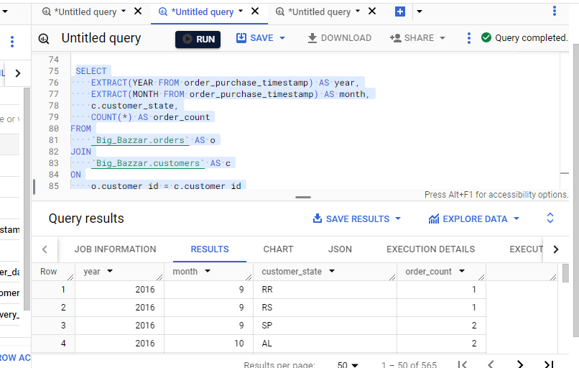

**Query**

SELECT

    EXTRACT(YEAR FROM order_purchase_timestamp) AS year,

    EXTRACT(MONTH FROM order_purchase_timestamp) AS month,

    c.customer_state,

    COUNT(*) AS order_count

FROM

    `Big_Bazzar.orders` AS o

JOIN

    `Big_Bazzar.customers` AS c

ON

    o.customer_id = c.customer_id

GROUP BY

    year,

    month,

    customer_state

ORDER BY

    year,

    month,

    customer_state;

**B** How are the customers distributed across all the states?

**Output**

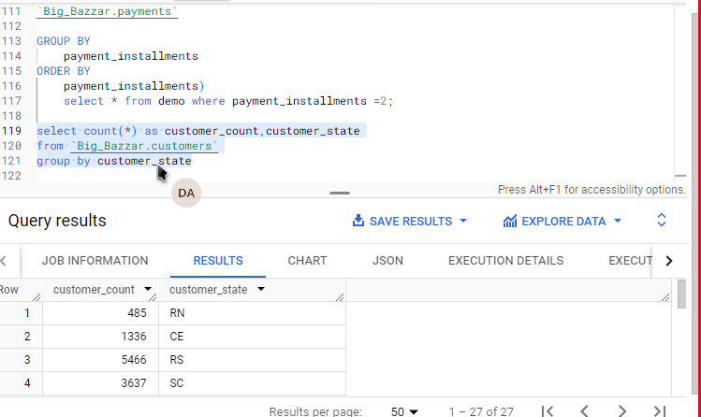

**Query**

select count(*) as customer_count,customer_state

from `Big_Bazzar.customers`

group by customer_state

**4. Impact on Economy: Analyze the money movement by e-commerce by looking at order prices, freight and others.**

**A** Get the % increase in the cost of orders from year 2017 to 2018 (include months between Jan to Aug only).

**Output**

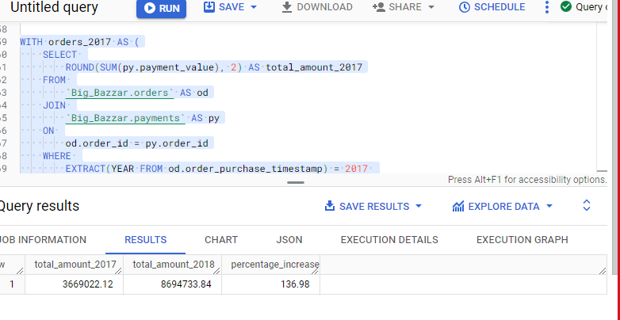

**Query**

WITH orders_2017 AS (

SELECT

ROUND(SUM(py.payment_value), 2) AS total_amount_2017

FROM

`Big_Bazzar.orders` AS od

JOIN

`Big_Bazzar.payments` AS py

ON

od.order_id = py.order_id

WHERE

EXTRACT(YEAR FROM od.order_purchase_timestamp) = 2017

AND EXTRACT(MONTH FROM od.order_purchase_timestamp) BETWEEN 1 AND 8

),

orders_2018 AS (

SELECT

ROUND(SUM(py.payment_value), 2) AS total_amount_2018

FROM

`Big_Bazzar.orders` AS od

JOIN

`Big_Bazzar.payments` AS py

ON

od.order_id = py.order_id

WHERE

EXTRACT(YEAR FROM od.order_purchase_timestamp) = 2018

AND EXTRACT(MONTH FROM od.order_purchase_timestamp) BETWEEN 1 AND 8

)

SELECT

o2017.total_amount_2017,

o2018.total_amount_2018,

ROUND(((o2018.total_amount_2018 - o2017.total_amount_2017) / o2017.total_amount_2017) * 100, 2) AS percentage_increase

FROM

orders_2017 AS o2017,

orders_2018 AS o2018;

**B** .Calculate the Total & Average value of order price for each state

**Output**

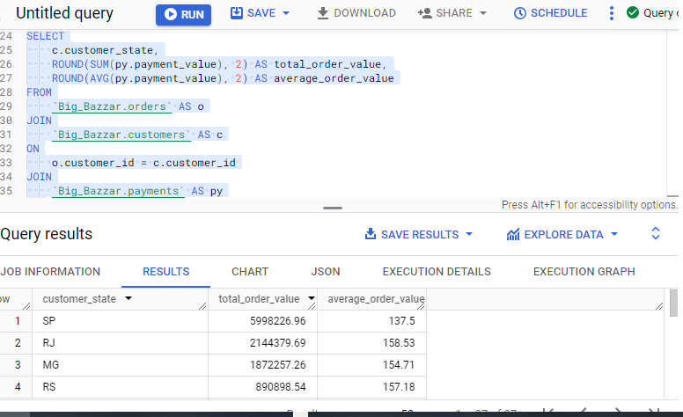

**Query**

SELECT

c.customer_state,

ROUND(SUM(py.payment_value), 2) AS total_order_value,

ROUND(AVG(py.payment_value), 2) AS average_order_value

FROM

`Big_Bazzar.orders` AS o

JOIN

`Big_Bazzar.customers` AS c

ON

o.customer_id = c.customer_id

JOIN

`Big_Bazzar.payments` AS py

ON

o.order_id = py.order_id

GROUP BY

c.customer_state

ORDER BY

total_order_value DESC;

**C** .Calculate the Total & Average value of order freight for each state

**Output**

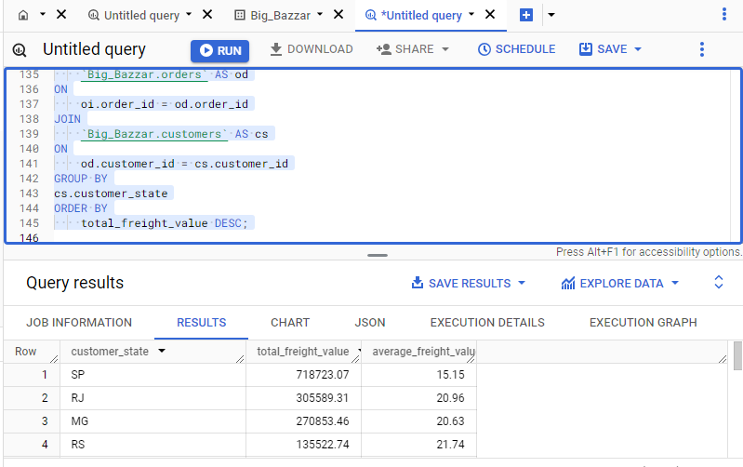

**Query**

SELECT

    cs.customer_state,

    ROUND(SUM(freight_value), 2) AS total_freight_value,

    ROUND(AVG(freight_value), 2) AS average_freight_value

FROM

    `Big_Bazzar.order_items` AS oi

JOIN

    `Big_Bazzar.orders` AS od

ON

    oi.order_id = od.order_id

JOIN

    `Big_Bazzar.customers` AS cs

ON

    od.customer_id = cs.customer_id

GROUP BY

cs.customer_state

ORDER BY

    total_freight_value DESC;

1. **Analysis based on sales, freight and delivery time.**

**A** Find the no. of days taken to deliver each order from the order’s purchase date as delivery time.  
Also, calculate the difference (in days) between the estimated & actual delivery date of an order.  
Do this in a single query.  
  
You can calculate the delivery time and the difference between the estimated & actual delivery date using the given formula:

* + - **time_to_deliver** = order_delivered_customer_date - order_purchase_timestamp

**diff_estimated_delivery** = order_delivered_customer_date - order_estimated_delivery_date

**Output**

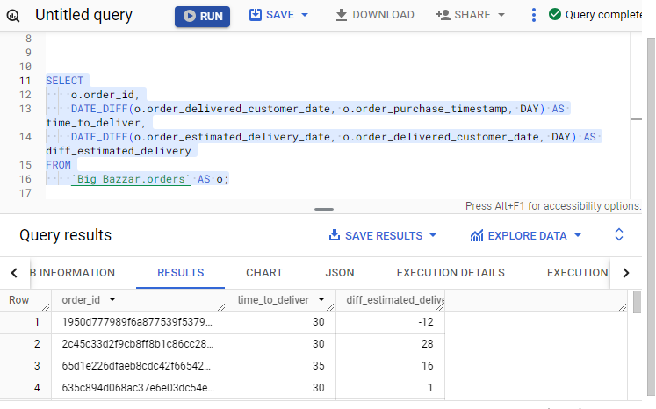

**Query**

SELECT

    o.order_id,

    DATE_DIFF(o.order_delivered_customer_date, o.order_purchase_timestamp, DAY) AS time_to_deliver,

    DATE_DIFF(o.order_estimated_delivery_date, o.order_delivered_customer_date, DAY) AS diff_estimated_delivery

FROM

    `Big_Bazzar.orders` AS o;

**B** .Find out the top 5 states with the highest & lowest average freight value

**Output**

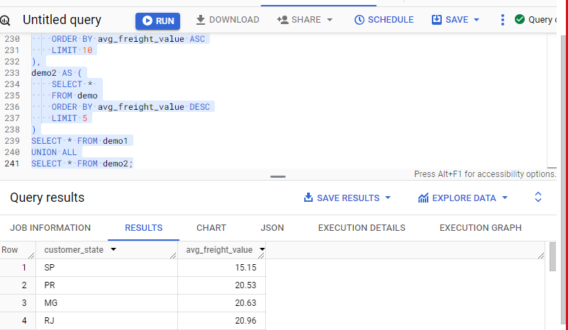

**Query:**

WITH demo AS (

    SELECT

        c.customer_state,

        ROUND(AVG(oi.freight_value), 2) AS avg_freight_value

    FROM

        Big_Bazzar.order_items AS oi

    JOIN

        Big_Bazzar.orders AS o ON oi.order_id = o.order_id

    JOIN

        Big_Bazzar.customers AS c ON o.customer_id = c.customer_id

    GROUP BY

        c.customer_state

),

demo1 AS (

    SELECT *

    FROM demo

    ORDER BY avg_freight_value ASC

    LIMIT 10

),

demo2 AS (

    SELECT *

    FROM demo

    ORDER BY avg_freight_value DESC

    LIMIT 5

)

SELECT * FROM demo1

UNION ALL

SELECT * FROM demo2;

**C** .Find out the top 5 states with the highest & lowest average delivery time

**Output**

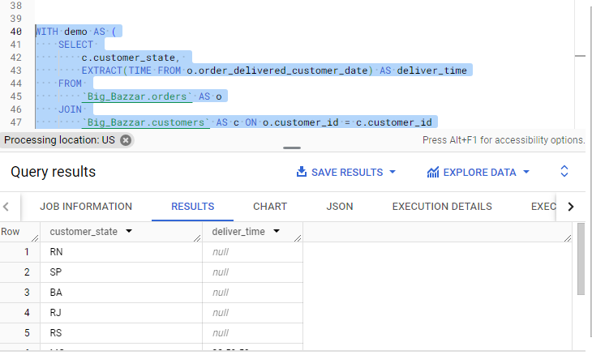

**Query**

WITH demo AS (

    SELECT

        c.customer_state,

        EXTRACT(TIME FROM o.order_delivered_customer_date) AS deliver_time

    FROM

        `Big_Bazzar.orders` AS o

    JOIN

        `Big_Bazzar.customers` AS c ON o.customer_id = c.customer_id

    GROUP BY

        c.customer_state, deliver_time

),

demo1 AS (

    SELECT

        customer_state,

        deliver_time

    FROM

        demo

    ORDER BY

        deliver_time ASC

    LIMIT 5

),

demo2 AS (

    SELECT

        customer_state,

        deliver_time

    FROM

        demo

    ORDER BY

        deliver_time DESC

    LIMIT 5

)

SELECT * FROM demo1

UNION ALL

SELECT * FROM demo2;

**D** .Find out the top 5 states where the order delivery is really fast as compared to the estimated date of delivery.  
You can use the difference between the averages of actual & estimated delivery date to figure out how fast the delivery was for each state.

**Output :**

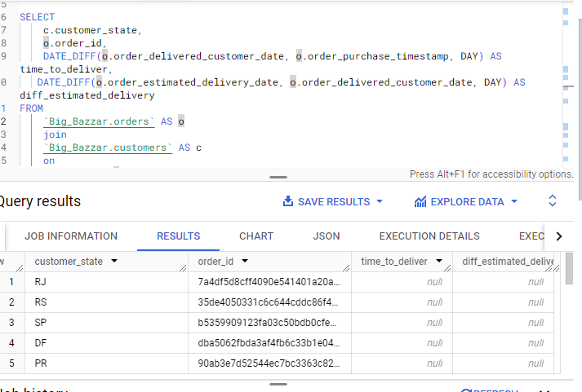

**Query :**

SELECT

    c.customer_state,

    o.order_id,

    DATE_DIFF(o.order_delivered_customer_date, o.order_purchase_timestamp, DAY) AS time_to_deliver,

   DATE_DIFF(o.order_estimated_delivery_date, o.order_delivered_customer_date, DAY) AS diff_estimated_delivery

FROM

    `Big_Bazzar.orders` AS o

    join

    `Big_Bazzar.customers` AS c

    on

c.customer_id = o.customer_id

limit 5

1. **Analysis based on the payments:**

**A** .Find the month on month no. of orders placed using different payment types

**Output**

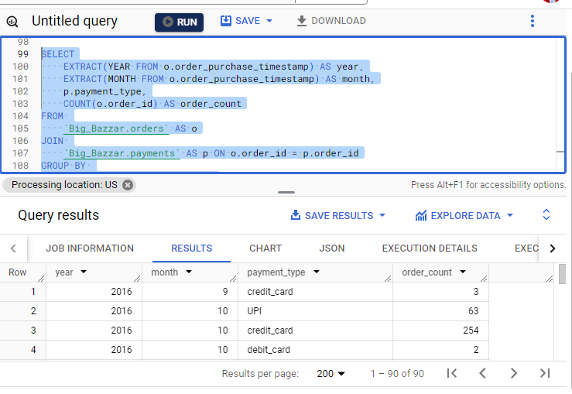

**Query**

SELECT

    EXTRACT(YEAR FROM o.order_purchase_timestamp) AS year,

    EXTRACT(MONTH FROM o.order_purchase_timestamp) AS month,

    p.payment_type,

    COUNT(o.order_id) AS order_count

FROM

    `Big_Bazzar.orders` AS o

JOIN

    `Big_Bazzar.payments` AS p ON o.order_id = p.order_id

GROUP BY

    year, month, p.payment_type

ORDER BY

    year, month, p.payment_type;

**B.** Find the no. of orders placed on the basis of the payment installments that have been paid.

**Output**

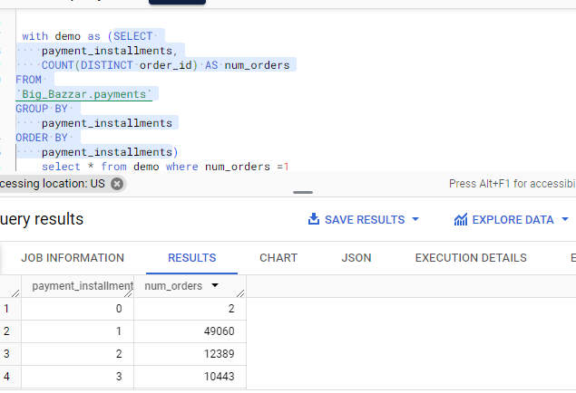

**Query**

with demo as (SELECT

    payment_installments,

    COUNT(DISTINCT order_id) AS num_orders

FROM

`Big_Bazzar.payments`

GROUP BY

    payment_installments

ORDER BY

    payment_installments)

    select * from demo where num_orders =1